Radiation Pattern and Scattering Properties of Optical Antennas
Zeyan Xu¹, Kevin Messer², and Eli Yablonovitch^{2*}
¹Department of Physics, University of Texas at Dallas
²Department of Electrical Engineering and Computer Science, University of California, Berkeley
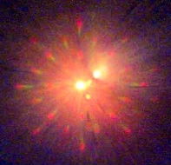
Email: emmaxu@berkeley.edu, kmesser@berkeley.edu, eliy@eecs.berkeley.edu

Abstract —when light emitting devices (e.g. LEDs) are coupled to optical antennas of the same resonance frequency, their spontaneous emission rate can be enhanced drastically. The ultimate goal is to have the rate of spontaneous emission faster than the stimulated emission so that the LEDs would be as fast as lasers and enable us to achieve energy efficient interconnects for on-chip communication. [1] In this project, we theoretically and experimentally measured the far field radiation pattern and the light scattering spectrum of a series of as-fabricated optical antennas. These measurements enabled us to characterize and better understand fundamental behaviors of optical antennas.
Figure: back focal plane image of a 2D grating

INTRODUCTION
Antennas are instruments designed to emit and receive wave signals. As essential components of wireless communication, antennas are implemented all over the world for various communication platforms. As an analogy to the conventional radio wave antennas, optical antennas function to emit and receive wave signals, but they are on the nanometer scale in order to interact with light waves. [2]
The principle of laser is to first create a population inversion of bosons with pumping and then utilize the stimulated emission to make it emit coherent light. The out coming photons collectively have the same phase and direction. Unlike lasers, many other light sources such as light-emitting diode (LED) uses the spontaneous emission of electrons to induce light. [3] The electrons vibrate and fall from excited state to the ground state at different frequencies and times, so the out coming light have different phases, these light will interfere with each other constructively and destructively, and make it orders of magnitude less efficient than lasers. In this paper, we demonstrate that with an optical antenna coupled to the light source with the same resonance frequency, we can enhance the rate of the spontaneous emission of the LED and therefore improve its energy efficiency. By doing so, we investigate in two main characteristics of optical antennas, their radiation pattern and scattering spectrum. For these two properties, we did both simulations and experiments to confirm results.

METHODS
One of the characteristics of antennas is its radiation pattern. Each antenna has its own intrinsic radiation pattern. By looking at the size and direction and the quantity of lobes, many qualities of the antenna can thus be determined. To image the radiation pattern, one needs an instrument called a conoscope. This is very similar to regular microscopes (orthoscopes), but instead of imaging the front focal plane that orthoscopes do, conoscopes can image the back focal plane of the image, therefore provide the radiation pattern. [4] In order to obtain such conoscope, one needs to do some engineering and alter certain parts of the microscope. In order to take the back focal plane image of a 2D grating, the key was to insert a pinhole right in front of the light source. The pinhole has a diameter of 75 micrometer. After that, it is necessary to add a Bertrand lens right in front of the camera. And then it is crucial to calculate where each lens should be and what should be the focal distance of the lenses.
We also did experiments on the scattering spectrum of the optical antennas. Learning about the scattering spectrum is important because it gives us information on the wavelength of emission, since wavelength is inversely related to resonance frequency, we are able to design antennas such that the frequency matches that of the LED therefore maximize the enhancement of the spontaneous emission rate, The key component in this experimental setup is the dark field beam splitter, it has a patch in the center of the aperture and its goal is to block the light in the center ring and reflect light in the outer ring. The light from the outer ring is the scattered light and it is then reflected and collected by a spectrometer.
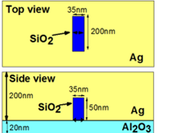
The antennas fabricated is of the structure to the left. There is a silicon oxide bar embedded inside a sliver film vertically, silver is 200 nm in thickness. The polarization direction of the antenna is then in the horizontal direction. The longitudinal dimension of the antenna is varied in our experiment to see the length dependence. The structure is protected by a layer of aluminum oxide to prevent silver from degrading.
Other than the experimental approach, simulations are also implemented to confirm results with the experiment. Finite-Difference Time-Domain (FDTD) simulation is the main method to theoretically calculate the radiation pattern and the scattering spectrum for a given antenna.

RESULTS & DISCUSSION
We used the conoscopy method to image the radiation pattern of an optical antenna, and we
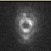
obtained the image to the left. From the image, we can see that the radiation pattern of the antenna has a donut shape surrounding the antenna. And then we also did simulations of the same antenna structure. We observe that the simulated radiation pattern is in the image shown below: 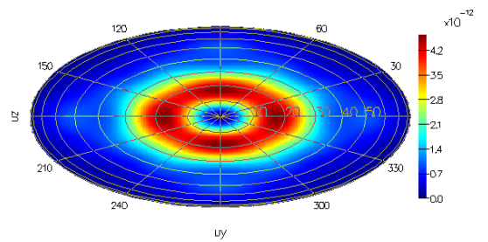
The simulated result also shows a donut shape encircling the antenna. So we can conclude that the radiation pattern of the antenna structure shown in the introduction should indeed have a donut shape. Knowing this, we can then experiment with different kinds of geometries of antennas to vary their radiation patterns for different application needs.
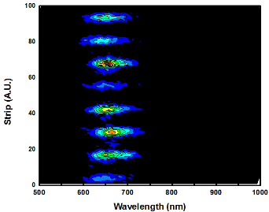
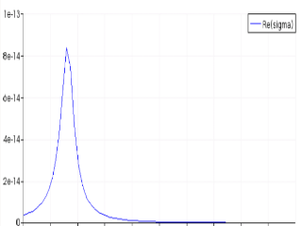
For the experiment for scattering spectrums of optical antennas, we had antennas with three kinds of longitudinal lengths: 100 nm, 200 nm, and 250nm. Below are the spectrum for them respectively:
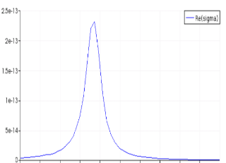
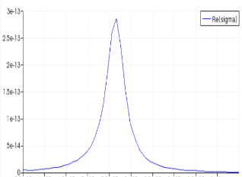
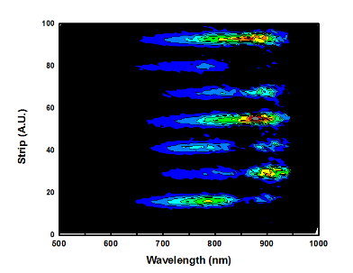
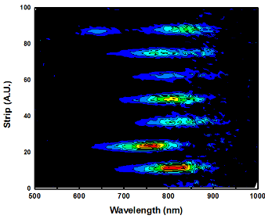

On the left we have scattering spectrum recorded with the spectrometer. On the right are the peak wavelengths of emission for each of the lengths of the antennas. It is also encouraging that the experimental data align well with simulated results. From the graphs we can see that the wavelengths of emission increased as the longitudinal lengths of the antennas increased. This agrees with theory and is also very important in antenna design, because the resonance frequency can then be calculated from the wavelength. Designing the resonance frequency to match the LED will give us the optimal enhancement of the antenna.

CONCLUSION
We observe that the wavelength of emission of optical antennas are dependent on its longitudinal length. The longer the antennas, the longer the wavelength of emission is, thus, shorter the resonance frequency. Knowing how the frequency is correlated to the length is important information when it comes to antenna design.
We observe that the simulations and experiments of the far field radiation pattern of the optical antennas agree. Knowing this, the next step is to try different geometries of antennas and see how that changes the radiation pattern. Being able to control the radiation pattern is a key factor in antenna design.
In the future, it is important to do photoluminescence experiments to quantify the exact enhancement we get for having those antennas compared to without them.

ACKNOWLEDGEMENT
The author would like to thank her Principal Investigator, Prof. Eli Yablonovitch for guidance, mentor Kevin Messer for technical help and Andy Michaels for help with simulations. The author would also like to thank Ms. Lea Marlor, James and Fanny for making this program and the summer enjoyable.

REFERENCE
[1] Novotny, L. & van Hulst, N. Antennas for light. Nature Photon. 5, 83–90 (2011).
[2] Eggleston, Michael S., et al. "Optical antenna enhanced spontaneous emission." Proceedings of the National Academy of Sciences 112.6 (2015): 1704-1709.
[3] Chemical Sciences: A Manual for CSIR-UGC National Eligibility Test for Lectureship and JRF/Atomic spectral line. En.Wikibook.org.
[4] Van Stryland, E., D. Williams, and W. Wolfe. Handbook of optics. Ed. Michael Bass. McGraw-Hill, 1996.

